Original article:
Prevalence of bony septae, antral pathology and dimensions of the maxillary sinus from a sinus augmentation perspective: A retrospective cone-beam computed tomography study
Dr.Vinamrata Tehri, Dr. Neeta V. Bhavsar , Dr. Mahesh Chavda, Dr. Sakshi Trivedi, Dr. Kirti Dulani, Dr. Nilam Brahmbhatt

Department of Periodontia , Govt.Dental College and Hospital Ahmedabad, Gujarat
Corresponding author*: Dr. Neeta V. Bhavsar
ABSTRACT
The implant placement in the maxillary posterior region requires the preoperative cbct scanning to visualize the presence of bony septae. Their presence increase the risk of occurrence of membrane perforation during sinus floor elevation. The prevalence of sepate also increase with age as the edentulous areas increase. The objective of the study was to examine the frequency, number and orientation of antral septae in maxillary sinus. Measurements were done on cbct scans of 35 patients(70 sinuses).The presence of 1 septa was seen in 18 sinuses (25.7%) followed by 2 septae in 14 patients (20%). Septae were most often vertically oriented. Based on their presence a classification system was proposed which consists of 3 categories- easy, moderate and difficult based on the location, orientation and size of antral septa, Corresponding treatment approaches were given for each category which may assist surgeons in managing antral septa during sinus augmentation.
Keywords: Cone beam computed tomography, Antral septae, Maxillary sinus, Implant
INTRODUCTION
Sinus elevation procedures have become a routine and reliable way to gain bone volume in the edentulous maxilla for dental implant placement. Implant placement in the edentulous posterior maxillary region is often complicated by the bony atrophy reducing the vertical height of bone. It will require sinus elevation procedures which is often complicated by the thickening of scheinderian membrane which occurs as a result of the presence of maxillary sinus septae. Maxillary antral septae are bony projections which most commonly arise from the floor of sinus which are the common anatomic variations. Naitoh et al suggested that septa may be a kind of reinforcement to hold the volume and shape of maxillary sinus and could be an effect of disharmony during the growth of bone surface sutures in the alveolar process and maxillary sinus. Van den Bergh et al. stated that septa are carrying masticatory forces during the dentate phase of life and after tooth loss they disappear. Neivert [33] proposed the idea that septa were derived from the “fingerlike projections” produced during embryological out-pouching of the ethmoid infundibulum in cases when the clinging wall did not resorb. Vinter et al. stated that they are an effect of the irregularly process of sinus floor atrophy in different regions creating “bony crests”, calling them secondary septa.
Among the many presented hypothesis Krennmair’s dichotomous division seems the most likely:
1) primary septa, formed during the development of bony head structures and the head’s height, increase with the growing process of the head; are formed along with the development of maxillary sinus.
2) secondary septa are formed after tooth loss in the process of maxillary alveolar atrophy.⁽⁷⁾
In 1910, the anatomist Arthur S. Underwood described sinus septa as thin, fragile and sickle shaped walls which are found more commonly in atrophic sinuses as comapared to dentulous areas so, their prevalence increases with age.
The longevity of the implants placed after sinus augmentation procedure is the same as that of conventional implants, so it is a very good option. Presence of bony septations and pathology in the maxillary sinus often cause complications leading to graft or implant failure or both.
The 2D OPG shows the overlapping structures and it is very difficult to assess the presence of maxillary sinus septa so it becomes very important to get a clear 3D view of the maxillary sinus region which can be done only by CBCT Scans as a measure of pre operative implant planning. There are many reasons for the sinus membrane perforation during the implant placement procedures which may include presence of septa, any infection or surgery, and also the surgeon’s expertise. Thus the information about the anatomy of the region including presence of maxillary sinus septae, their orientation, and any pathology will be necessary for the successful placement of dental implant.
AIMS AND OBJECTIVES
The aim of this study was to retrospectively evaluate the prevalence, direction of the septa, and sinus width measured at 2 mm, 5 mm, and 10 mm from the sinus floor using cone beam computed tomography (CBCT).
METHODOLOGY
70 sinuses from 35 random preoperative CBCT scans referred for implant therapy are retrospectively evaluated for the number, prevalence, and direction of bony septations.
Width of the sinus was also measured at 2 mm, 5 mm, and 10 mm from the sinus floor to account for the amount of bone available for implant placement.
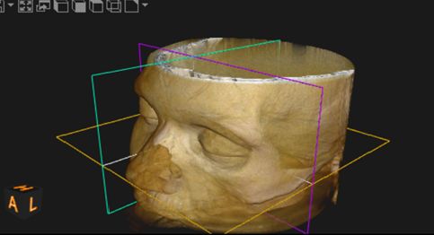

Fig(A) showing the skull divided into coronal,
sagittal and transverse sections

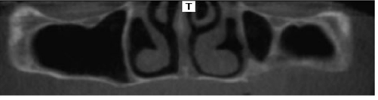
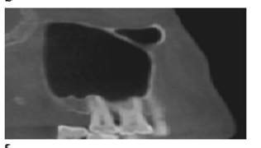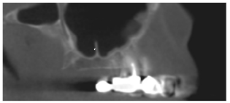
Sagittal (B) Coronal (C)Transverse
Fig(B) Maxillary sinus septae in different sections⁽¹⁾

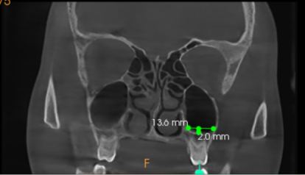
Fig(C) Coronal section showing the width of maxillary sinus at 2 mm
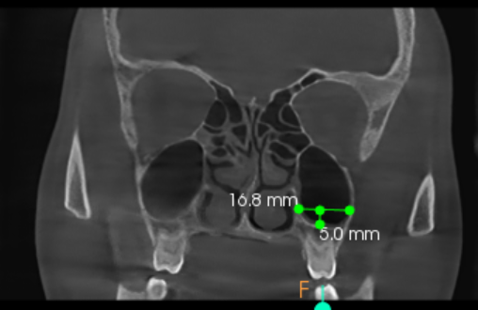
Fig(D) Coronal section showing the width of maxillary sinus at 5 mm

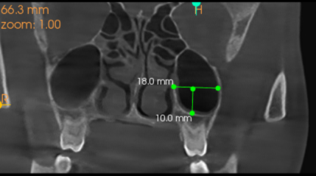
Fig( E) Coronal section showing the width of maxillary sinus at 10 mm

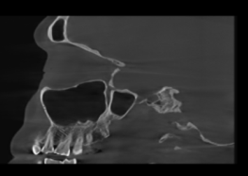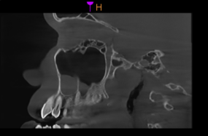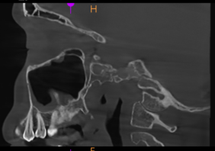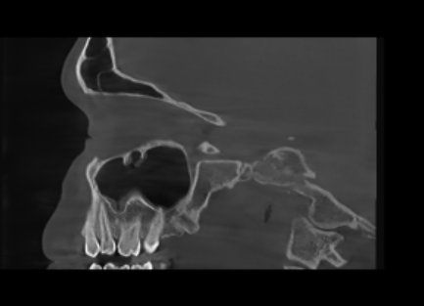
- (2) (3) (4)
Fig (F) The different orientation of maxillary sinus septae in sagittal sections (1) The septa dividing the maxillary antrum into 2 compartments (2), (3) Incomplete vertical septa arising from the floor of the sinus (4) 2 incomplete sepate

RESULTS

Table 1: The number of maxillary sinuses according to the number of septa
No. of septa | Number of sinuses | %Prevalence
1 septum | 18 | 25.7
2 septa | 14 | 20
3 septa | 5 | 7.1
4 septa | 2 | 2.8

Table 2: The dimensions of the sinuses ( n=70 ) at the level of 2 mm, 5mm and 10 mm cranial to the sinus floor

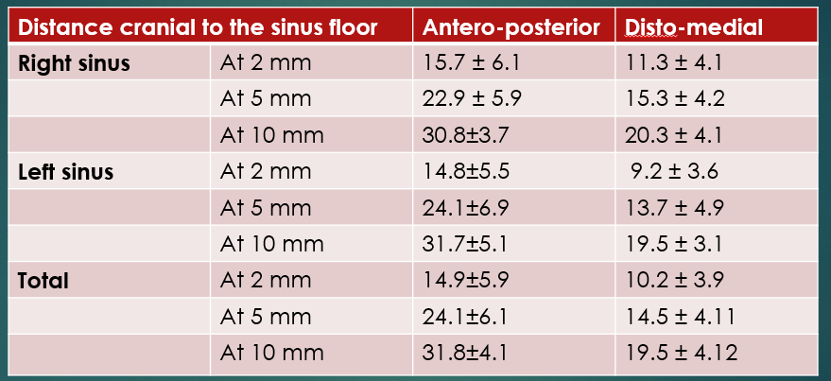

Table 3: The maximum dimensions of the sinuses(n=70) (mean±standard deviation, range; unit: mm)
 | Antero- posterior | Medio lateral (Distomedial) | Cranio-caudal
Right sinus | 36.1±4.5  (25.6-45.0) | 38.2±3.8  (28.2-48.6) | 27.6±5.2  (18.0-44.3)
Left sinus | 36.4±4.7  (21.2-45.0) | 38.4±3.2  (30.2-44.3) | 26.8±3.7  (18.8-34.3)
Total | 36.2±4.6  (23.1-46) | 38.2±3.4  (28.2-48.3) | 27.2±4.3  (18.2-44.2)

DISCUSSION
In the present study, Maxillary sinus septa was present in 39 sinuses (55.7%) out of 70. [Table1], according to the study done by Tadanida et al in 2016, the prevalence was found to be 43 sinuses (59.7%) out of 72 which is similar with this study.In a radiographic study, Bornstein et al. analysed unilateral and bilateral CBCT scans of 212 patients and found septa in 142 sinuses (67%) of 212 patients and 168 sinuses (57%) of 294 maxillary sinuses. These numbers are higher than those found in the present study. The differences might be explained by the higher mean age of the patients, being associated with a higher proportion of edentulous patients.
Presence of 1 septum is found in 18 sinuses (25.7%) [Table1] while presence of 2 septae seen in 14 sinuses (20%) out of 70 sinuses examined while according to the study done by Tadanida et al in 2016, the presence of 1 septum is seen in 20 sinuses (27.7%) followed by 2 septae in 17 sinuses (23.6%) out of 72 similar to the present study. According to the study done by Mehmet Emin Toprak et al in 2020, maxillary sinus septae were found to be in 132 (22%) out of 600 maxillary sinuses observed. 1 septa was found in 167(89.3%) sinuses 2 septa were found in 19(10.17%) sinuses.⁽⁸⁾
Dragan et al. found an even higher prevalence of septa in the posterior region. Analyzing CBCT scans of 100
edentulous patients and 100 dentate patients, they showed septa in 96 and 98 of patients, respectively.
A systemic review by Pommer et al. included studies published between 1995 and 2011 and found a prevalence of septa in 2498 sinuses (28%) of 8923 sinuses.
The most common direction of the septa in this study is vertical in contrast to the study done by A. Hungerbuhler
et al in 2018, in which it was found to be transverse.Gonzalez-Santana et al in 2007 described them to be
prevalent in the middle region similar to the observation in this study.
On the basis of the present CBCT scan study, a choice between long and short implants is done.The choice should be based on the desired implant position with regard to prosthodontic situation and sinus related factors like possible septa in the region of a future sinus floor elevation. A septum in the area of desired implant position may speak in favor of short implant while lack of septum for long implants.
The presence of septa in the floor causes Schneiderian membrane thickening causing difficulty in it’s elevation so proper preoperative assessment is needed to be done before sinus lifting procedures.

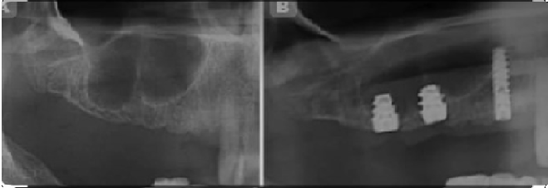

Fig (G) The presence of septa favors the placement of short implants while their absence
marks the placement of long implants

According to the study done by Shih- Cheng Wen et al in 2013, the various treatment approaches for the different categories of septa is given. For the septae located anterior to zygomatic process, 1 window with the wall off/ wall-gone technique or 2 window treatment approach can be taken. For the septae located posterior to the zygoma 1 window with the wall-off/ wall-gone technique or osteotome technique can be taken while for the maxillary antral septae located anterior or posterior to zygomatic process antero-posteriorly oriented, 1 window from the lateral approach, and 1 window from the crestal approach and the wall-gone technique can be done. The Limitations of the study was that the sample size is small so more studies are needed to be done for more reliable research purpose. The treatment approach for the management of different maxillary sinus septae was not proposed which can be a surgical guide to the clinicians for the management of maxillary sinus septae given by Wen et al in 2013.
CONCLUSION
Based on the high prevalence of septa and sinus pathology in this sample, a preoperative CBCT scan might be helpful in minimizing complications during sinus augmentation procedures for dental implant therapy.

REFERENCES
1.Hungerbühler A, Rostetter C, Lübbers HT, Rücker M, Stadlinger B. Anatomical characteristics of maxillary sinus septa visualized by cone beam computed tomography. International Journal of Oral and Maxillofacial Surgery. 2019 Mar 1;48(3):382-7.
2.Tadinada A, Jalali E, Al-Salman W, Jambhekar S, Katechia B, Almas K. Prevalence of bony septa, antral pathology, and dimensions of the maxillary sinus from a sinus augmentation perspective: A retrospective cone-beam computed tomography study. Imaging science in dentistry. 2016 Jun 1;46(2):109-15.
3.Wen SC, Chan HL, Wang HL. Classification and management of antral septa for maxillary sinus augmentation. International Journal of Periodontics & Restorative Dentistry. 2013 Jul 1;33(4).
4.Maestre-Ferrín L, Carrillo-García C, Galán-Gil S, Peñarrocha-Diago M, Peñarrocha-Diago M. Prevalence, location, and size of maxillary sinus septa: panoramic radiograph versus computed tomography scan. Journal of oral and maxillofacial surgery. 2011 Feb 1;69(2):507-11.
5.Selcuk A, Ozcan KM, Akdogan O, Bilal N, Dere H. (2008). Variations of maxillary sinus and accompanying anatomical and pathological structures. J Craniofac Surg, 19: 159-164.
6.Fourth Edition, Misch’s Contemporary Implant Dentistry by Randolf R. Resnik
7. Malec M, Smektała T, Trybek G, Sporniak-Tutak K. Maxillary sinus septa: prevalence, morphology, diagnostics and implantological implications. Systematic review. Folia Morphologica.2014;73(3):259-66.
8. Maxillary sinus septa and anatomic correlation with the dentition type of sinus region: a cone beam computed tomography study Mehmet Emin Toprak, Mustafa Sancar Atac et al; August 2020.

